Waggle run distributions quantify collective foraging in honey bee colonies

Joseph Palmer, Ash Samuelson, Elli Leadbeater and Vincent Jansen

# Abstract

Honeybee foraging is an extraordinary collective behaviour that is directed through the celebrated waggle dance communication system, whereby colony foraging effort is allocated through a series of feedback loops (Frisch 1967; Seeley 1995). Here, we present a mathematical model that quantifies the extent to which honeybee colonies behave collectively in different ecological environments by inferring the proportion of dances performed by bees that have explored individually, and those that have been recruited to food sources. By applying this methodology to waggle dance data from twenty hives, we show that colonies are less reliant on dance information where resources are sparse, potentially because colonies are required to send out more scouts to find food in these circumstances. Our methodology provides a tool to identify those ecological conditions in which honeybee colonies rely on dance communication, and so to understand the selection pressures that may have driven the evolution of this remarkable collective behaviour.

# Main

Within honeybee colonies, a series of simple rules that determine when and how much bees perform the celebrated waggle dance (Figure of dance waggle dance) mean that choices between feeding sites occur at the level of the group rather than the individual. For example, because the number of dance circuits performed by a bee on returning from a food source reflects the net energetic benefits of the trip, more of the colony’s workforce will be recruited to the sweeter of two equidistant sources (Seeley, Camazine, and Sneyd 1991), or the closer of two equally sweet sources (Hasenjager, Hoppitt, and Leadbeater 2022), without requiring any individual bee to compare options. This extraordinary system is a key example of how social insect colony behaviour can take on a form extending beyond that of the individual units (Sumpter 2006).

Despite such impressive complexity, a wealth of research now shows that foraging bees frequently do not use dance information to find forage sites (Grüter and Farina 2009). Accordingly, in many situations, colonies that are prevented from communicating via dances achieve equal or even greater foraging success than their wild-type counterparts (Sherman and Visscher 2002; Dornhaus et al. 2006; Grüter, Segers, and Ratnieks 2013; Price et al. 2019). This apparent variation in the use of collective behaviour is intriguing because it may provide clues as to those ecological selection pressures that were critical in the evolution of the dance communication system. Despite the extraordinary amount of research interest that has focused on the proximate mechanisms of collective decision-making via dance communication, the ultimate evolutionary drivers of its unique evolution within *Apis* -unparalleled in even a single other social insect- remain obscure (Price and Grüter 2015). Identifying those circumstances in which bees use the dance is likely to be a key step towards understanding when it is likely to afford fitness benefits at the colony level, but attempts to do so are challenging because they require constant monitoring of real-world colony weight (Kirchner and Grasser 1998; Sherman and Visscher 2002; Dornhaus et al. 2006; Grüter, Segers, and Ratnieks 2013; Nürnberger, Steffan-Dewenter, and Härtel 2017; Price et al. 2019) -a noisy proxy of foraging success that is influenced by many other abiotic and biotic factors, including colony health- over ecologically credible time periods (Schürch and Gruẗer 2014). To do this at a scale that allows inter-colony variation in foraging environments at sufficient replication is a major logistical hurdle (but see (Nürnberger, Steffan-Dewenter, and Härtel 2017)).

[figure of waggle dance]

*Honeybees provide an ideal study system in which to evaluate collective foraging thanks to the famous “waggle dance”, which conveys information about location of a resource as a vector of distance (duration of the waggle run) and direction (angle of the dance relative to the sun) (Frisch 1967).Through the observation and decoding of the waggle dance, a colony’s dance floor provides a unique opportunity to eavesdrop on the communication and decision making leading to collective foraging decisions. Resource “quality” is provided through the number of waggle runs performed (Frisch 1967; Boch 1956; Esch 1961; Thomas D. Seeley and Tovey 1994; Seeley, Mikheyev, and Pagano 2000). Although bees that follow dances do not specifically interpret this information on an individual level (Seeley, Camazine, and Sneyd 1991), the resulting over-representation of high-quality sites on the dance-floor means that they are more likely to encounter dances that advertise better forage (Seeley 1995), and provides the colony with a mechanism to select the most profitable resources in their environment (Thomas D. Seeley 1994).*

[end of figure of waggle dance]

Here, we present a a model that can identify the proportion of foraging trips that are made by bees recruited through waggle dances, and thus quantify collective behaviour, in unmanipulated hives with no requirement to manipulate hive orientations or assay foraging efficiency. Our model seeks to distinguish between “scout” foraging trips, in which food sources that have been located through individual search are reported by waggle dancing, and “recruit” trips in which a forage site is found by using the information provided in the dance of another bee (Seeley 1995). Scouting and recruiting are not fixed behavioural categories, because individual bees can engage in both over the course of their foraging lifetime, and foragers can dance on return from any successful trip irrespective of whether they were recruited to the forage site or found it individually (Beekman et al. 2007). In a hypothetical colony that relied only on individual search to find foraging sites, all trips would be “scout” trips, but as recruitment becomes more important, the proportion of “recruit” trips will increase. Previously, scout and recruit trips have only been distinguishable by means of the foragers’ individual search history, which requires following individual bees and is time and labour intensive (Seeley 1995).

To reveal how the patterns of waggle dance encoded foraging distances might differ under a scout and recruit foraging strategy, we simulated honeybees foraging in a landscape where resource patches were randomly placed in the environment. Foragers could locate these under two different strategies: either acting as a scout and locating resources themselves, or following a recruit strategy and locating resources by following a random dance from the dance floor (Seeley and Towne 1992) (Fig. 1). As it is known in the simulation which individuals forage under what strategy, we can compare the distributions of foraging distances reported on the dance floor. Figs 1c and 1d show that the shapes of the resource distance distributions for the two types of foraging trips are very different. The distance distribution of the scouts is akin to that of an exponential distribution (Fig. 1 C), which is the nearest neighbour distance distribution for foragers operating in a one-dimensional environment (see methods). The distribution of the distances reported by recruits (Fig. 1 D) is a Rayleigh distribution which is the nearest-neighbour distribution of a two-dimensional environment (Pyke 1978) (see Methods).

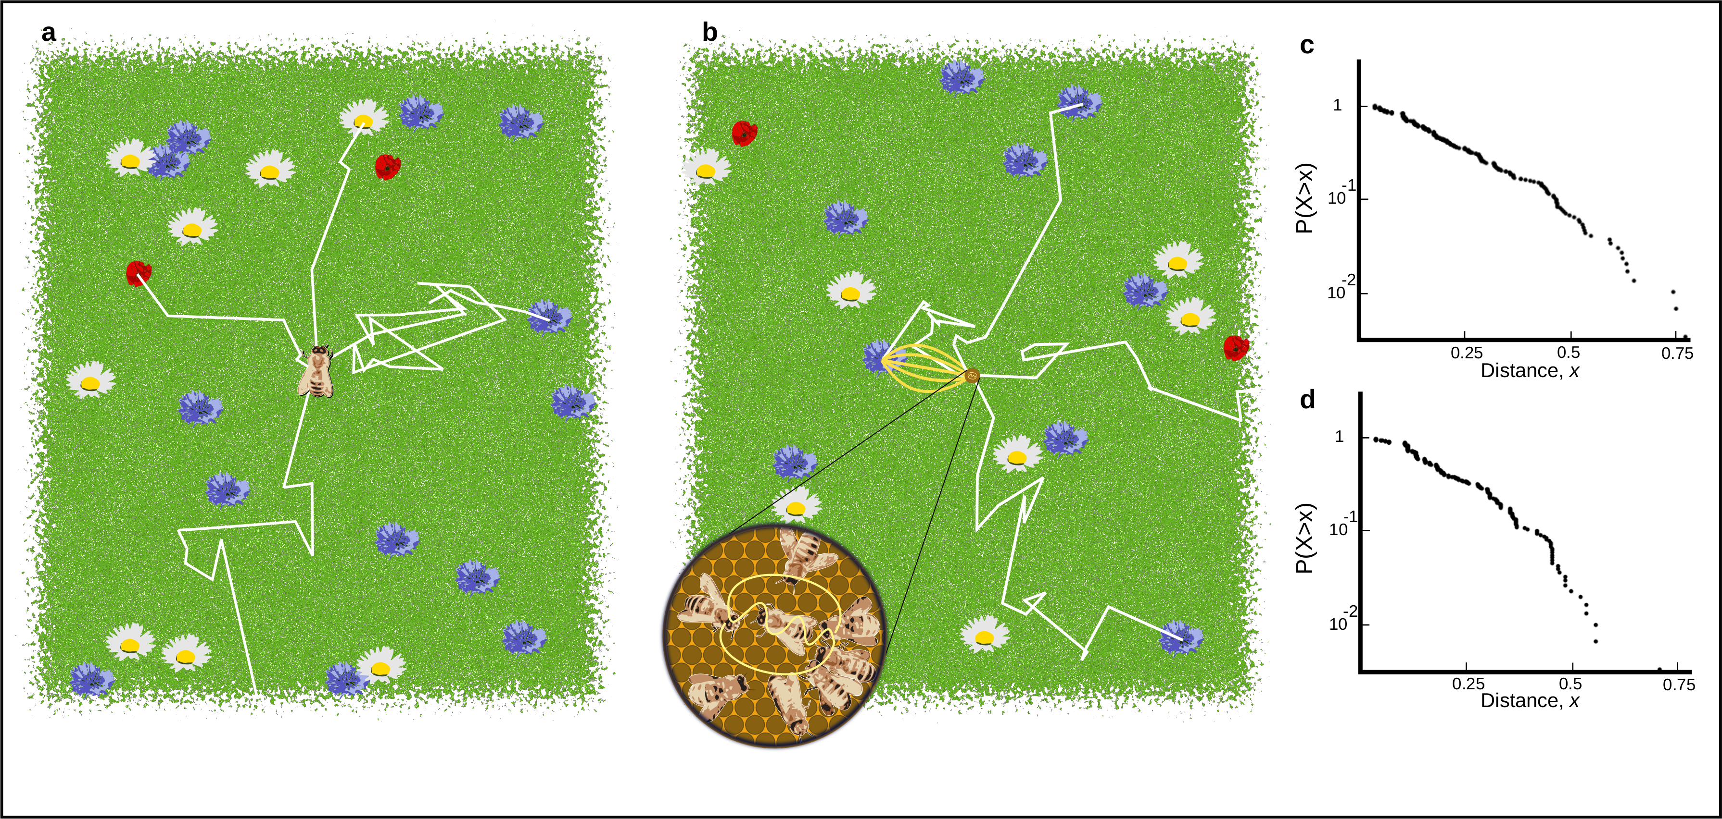

Figure 1. A. Outline of individual foraging. Foragers leave the hive on a random flight path (white lines) and continue until they encounter a resource (flowers in the figure). B. Outline of foraging with recruitment. Some foragers (scouts) continue to identify resources but others (recruits) sample available dances provided by scouts and other recruits. C. Log inverse frequency distribution of foraging distances reported by scouts. D. Log inverse frequency distribution of foraging distances reported by recruits. Here, inverse frequency distribution refers to probability of sampling a value greater than $X$.

Scouts and recruits create different waggle run distributions on the dance-floor. These different distributions can be used to quantify the relative importance of collective foraging. Scouting foragers report a distribution of distances that reflects their probability of encountering a resource in the environment (see methods), whilst recruits report distances that reflect the distribution of the most profitable resources available (see methods). On the dance-floor, the distribution of distances is modified through the number of runs performed for a resource, which depends on the profitability of a resource, which honeybees achieve by measuring the energetic efficiency of a foraging trip through the ratio of energetic gain to energetic cost (Thomas D. Seeley 1994). By combining this profitability with the distributions identified in our simulations, we develop a novel method to describe the distribution of waggle runs reported on the dance-floors of real honeybee colonies as a superposition of scout and recruit distributions (Fig 2, see Methods).

This method intrinsically captures honeybee foraging as collective decision making, as the foraging sites represented on the dance floor derive from a mixture of individual search and waggle dance information, captured in the proportions $p$ and $1−p$, respectively. Consequently, by setting $p=1$, we can also derive a model based on the sole use of individual search (scouts only) (Fig 2). By fitting these two models to distribution of waggle run durations decoded from real honeybee colonies we are thus able, using model selection (Burnham and Anderson 2002), to infer if and, by estimating the parameter $p$, to what extent honeybee colonies use waggle dance information when foraging.

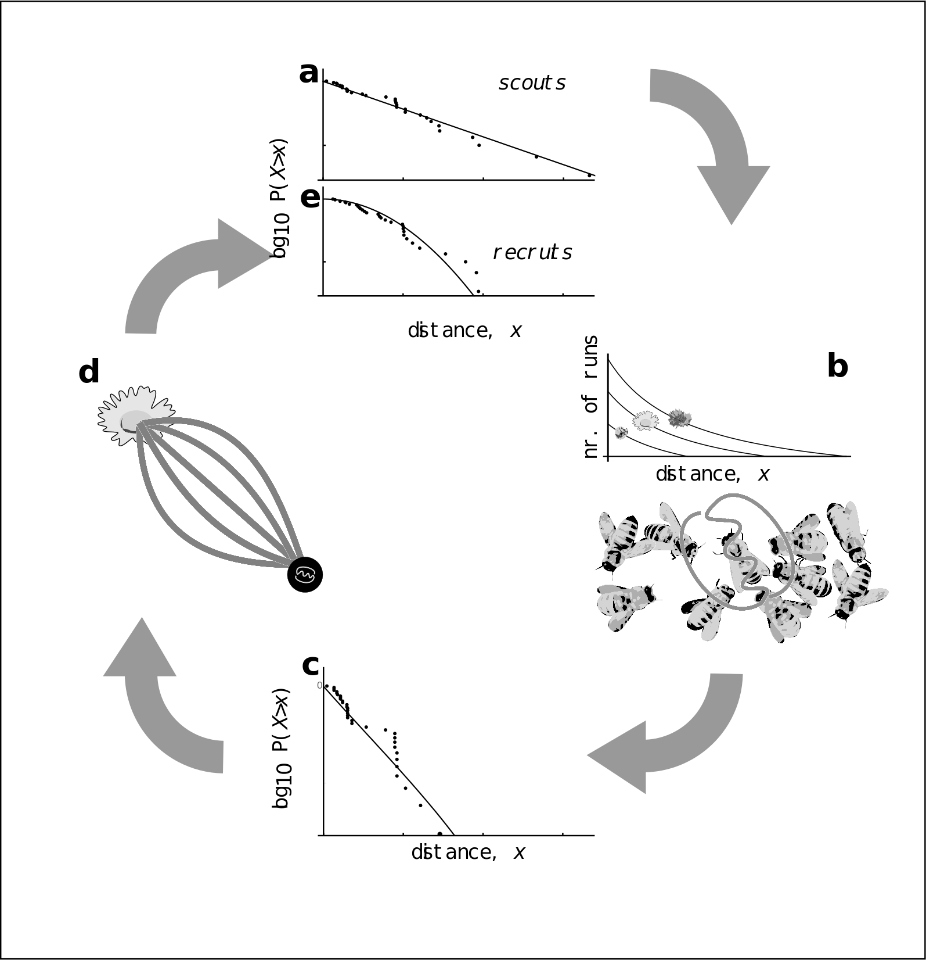

Figure 2: Model of honey bee foraging. Flowers advertised by scouts are distributed exponentially (a). These dances are advertised on the dance floor (b) in relation to their profitability, meaning sampling recruits are biased to the more profitable (and closer) resources (c). After visiting advertised resources, recruits also dance for them leading to higher recruitment (d) which overall skews the distribution of distances reported on the entire dance floor (e).

To evaluate the use of waggle dance information and individual search in honeybee colonies foraging in ‘natural’ landscapes, we analysed a pre-existing dataset of 3378 waggle dance observations from 20 observation hives, recorded between April-September 2017, (previously described in (Samuelson, Schürch, and Leadbeater 2021)). Hives that contributed to this dataset had been situated at different locations in South East England (see methods, figure 3A) and visited every two weeks for a period of 24 weeks. On each visit, two hours of continuous waggle dance data was recorded by training a camcorder onto the dance floor. The footage of the dances was decoded manually (Couvillon et al. 2012; Schürch et al. 2019) to extract waggle run durations. Using this data, for each site we fit both the collective and individual models and used model selection to determine which provided the better explanation of the data, and (if the collective model provided a better fit) to quantify the relative use of social information through estimating the parameter p. We calculated the goodness-of-fit using a Kolmorgorov-Smirnov (KS) test to ascertain if the model provided a plausible explanation of the data (Goldstein, Morris, and Yen 2004).

For 17 out of 20 study hives, a model of collective foraging provided a better explanation of the data than one of individual foraging (Fig. 3a). In all but one of these cases, the collective model had a good fit (using a Kolmogorov-Smirnov statistic, see methods) to the empirical waggle run durations, whereas for 9 of these sites, the distribution predicted by the scout model was significantly different to the observed data (Fig. 3b). The sites STU and ZSL shown in Figs 3c-d are representative examples showing the model fits where the collective (STU) and individual (ZSL) models fit best, showing the overall quality of the model fit to the data.

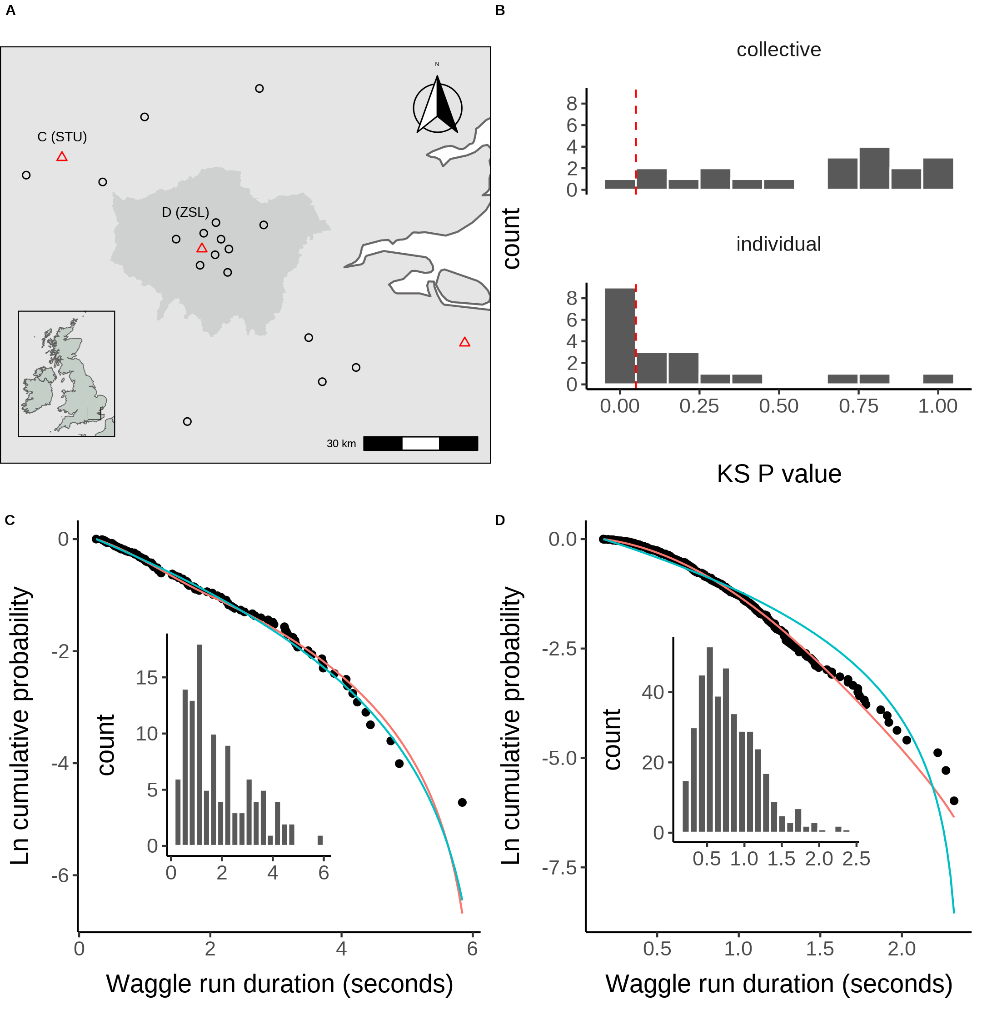

Figure 3. A. Location of study hives in Southern England coloured by which model, collective (black circles) or individual (red triangles) provided the best explanation of the data as indicated by lowest AIC score. Sites STU and ZSL (C & D) are marked. Inset plot shows the location of the sites within the UK; shaded area in the main plot indicates Greater London. B. Distribution of goodness of fit confidence values for each model fit to waggle run durations from each site. P value is derived from a bootstrapped two-sided KS test comparing the fitted model predictions to the empirical data. The red dashed line marks the significance threshold of 0.05. Values greater than 0.05 indicate no statistically significant difference is observed between the model and the data, indicating the model provides a good fit to the data. C. Model fits to waggle run durations collected from the STU hive, for which the collective model (red line) did not outperform the individual model (blue line), along with histogram showing distribution. D. Model fits to waggle run durations collected from the ZSL hive, where the collective model (red line) outperformed the individual model (blue line), along with histogram showing distribution. Model fits show the compliment cumulative frequency distribution, giving the probability of sampling a value greater than or equal to x.

These results show that, whilst colony-level foraging is mostly comprised of a mixture of scout and recruit foraging trips, in some circumstances, colony foraging can be better described by individual foraging alone. This suggests that in some environments honey bees mainly engage in scouting to find new food sites rather than follow dances. Previous empirical studies have shown that individual foragers may flexibly alter their use of waggle dance information if its use is proving unproductive (Grüter and Ratnieks 2011; Price et al. 2019). Evaluating how these individual decisions influence the collective, however, has historically been a challenge as it is effectively impossible to track an individual’s foraging behaviour over a landscape. As our results show that individual foraging accurately describes colony foraging in three different sites, these findings support the idea that individual decision making can dominate colony foraging and demonstrates further evidence for flexible waggle dance use by honey bee colonies.

Further quantification of the use of waggle-dance recruitment within all colonies, as a proportion of all foraging trips, can be achieved by extracting the estimated proportion of scout trips (p) for each site. Since our sites varied in land-use characteristics and potentially thus forage distributions (although in this case, not by design for this study), we investigated whether these estimates might correlate with land-use. We first classified the different land-use types of the area surrounding each site (Samuelson and Leadbeater 2018) to obtain a standardised land-use profile for the urban and agri-rural environments separately as many land-use types present in urban areas do not occur in agri-rural environments and vice versa (see methods). We then performed a Partial Least Squares (PLS) analysis (Carrascal, Galván, and Gordo 2009) (see methods) to determine the principal components that represent combinations of land-use types which explained the most variation in the proportion of scout dances within agri-rural and urban environments. As we have a small sample size (20 sites; 10 urban and 10 agri-rural), this analysis was jackknifed to evaluate the robustness of our results to influential points (see methods, supplementary material section *.*)

In the agri-rural environments one combination of land use types explained ~52% of the variation in the proportion of scouts (beta regression: $R^{2}=0.52$, $ϕ$ = 3.7, p < 0.05, Fig. 4. A). This principal component correlates positively with arable land (29% of land coverage; Table 1) and negatively with built-up areas (17% of land coverage) ; it also correlates negatively with non-agricultrual unmanaged green space and water, but together these represent less than 3% of land-use (Fig. 4. B). These land-use types maintain a significant correlation with PC1 over the jackknifed PLS (Fig. 4. B) indicating the results are robust. As arable land increases whilst built-up areas decrease, the proportion of trips that are driven by individual search increases.

**Table** : Percentage area covered for each land-use type in the agri-rural environment

| **Land-use** | **% coverage** |
| --- | --- |
| Arable | 28.80 |
| Pasture | 21.70 |
| Woodland | 20.00 |
| Built Up Area | 16.80 |
| Fruit | 2.88 |
| Oilseed Rape | 2.88 |
| Non Agricultural Managed Green Space | 2.75 |
| Non Agricultural Unmanaged Green Space | 2.65 |
| Other Agricultural | 1.52 |
| Water | 0.16 |

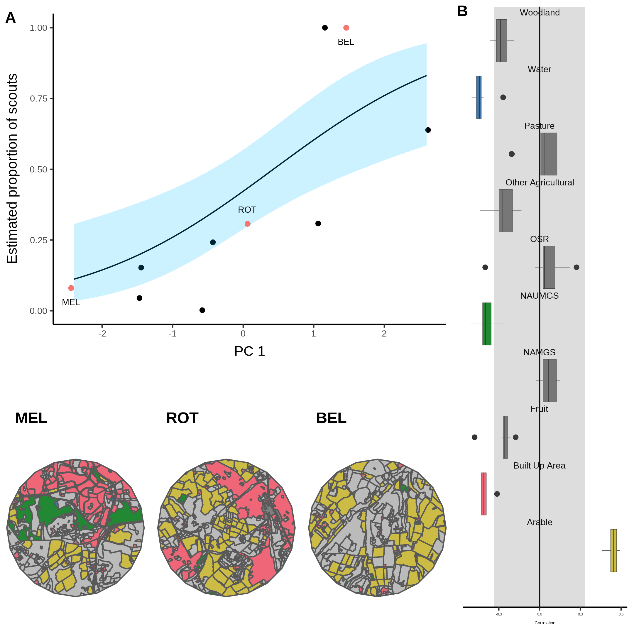

Figure 4. A. Estimated proportion of scouts for each site in the Agri-rural landscape against the first principle component derived from a Partial Least Squares analysis of land-use type. A beta regression shows the relationship (black line) between PC1 and the proportion of scouts, with 95% CI shown by the blue shaded area. B. Loadings for PC1 showing the correlations between PC1 and each land-use type (NAUMGS stands for Non-agricultural unmanaged green space). All points outside the shaded area significantly contribute to PC1. The colours of these land-use types are shown in the local environment of sites MEL, ROT and BEL (maps in bottom left) chosen as representative sites along the model gradient.

A similar effect was observed in the urban environment, where a single PC explained ~59% of the variance in the proportion of scouts (beta regression: $R^{2}$ = 0.59, $ϕ$ = 6.2, p < 0.05, Fig. 5. A). This PC correlates positively with parks, allotments and cemeteries (8% of land cover; Table 2), whilst correlating negatively with sparse residential lands (35% of land cover) and railways, but these represent only 1% of land cover. (Fig. 5. B). However, we have low confidence in this finding because the jackknifed PLS identifies CAD as a highly influential site, the removal of which causes sparse residential land to have a positive correlation with PC1 (Supplementary Material *.*).

**Table** : Percentage area covered for each land-use type in the agri-rural environment

| **Land-use** | **% coverage** |
| --- | --- |
| Sparse Residential | 34.80 |
| Continuous Central | 24.30 |
| Dense Residential | 21.80 |
| Parks Allotments Cemeteries | 7.88 |
| Woodland | 4.22 |
| Water | 3.36 |
| Amenity Grassland | 2.62 |
| Railway | 1.04 |

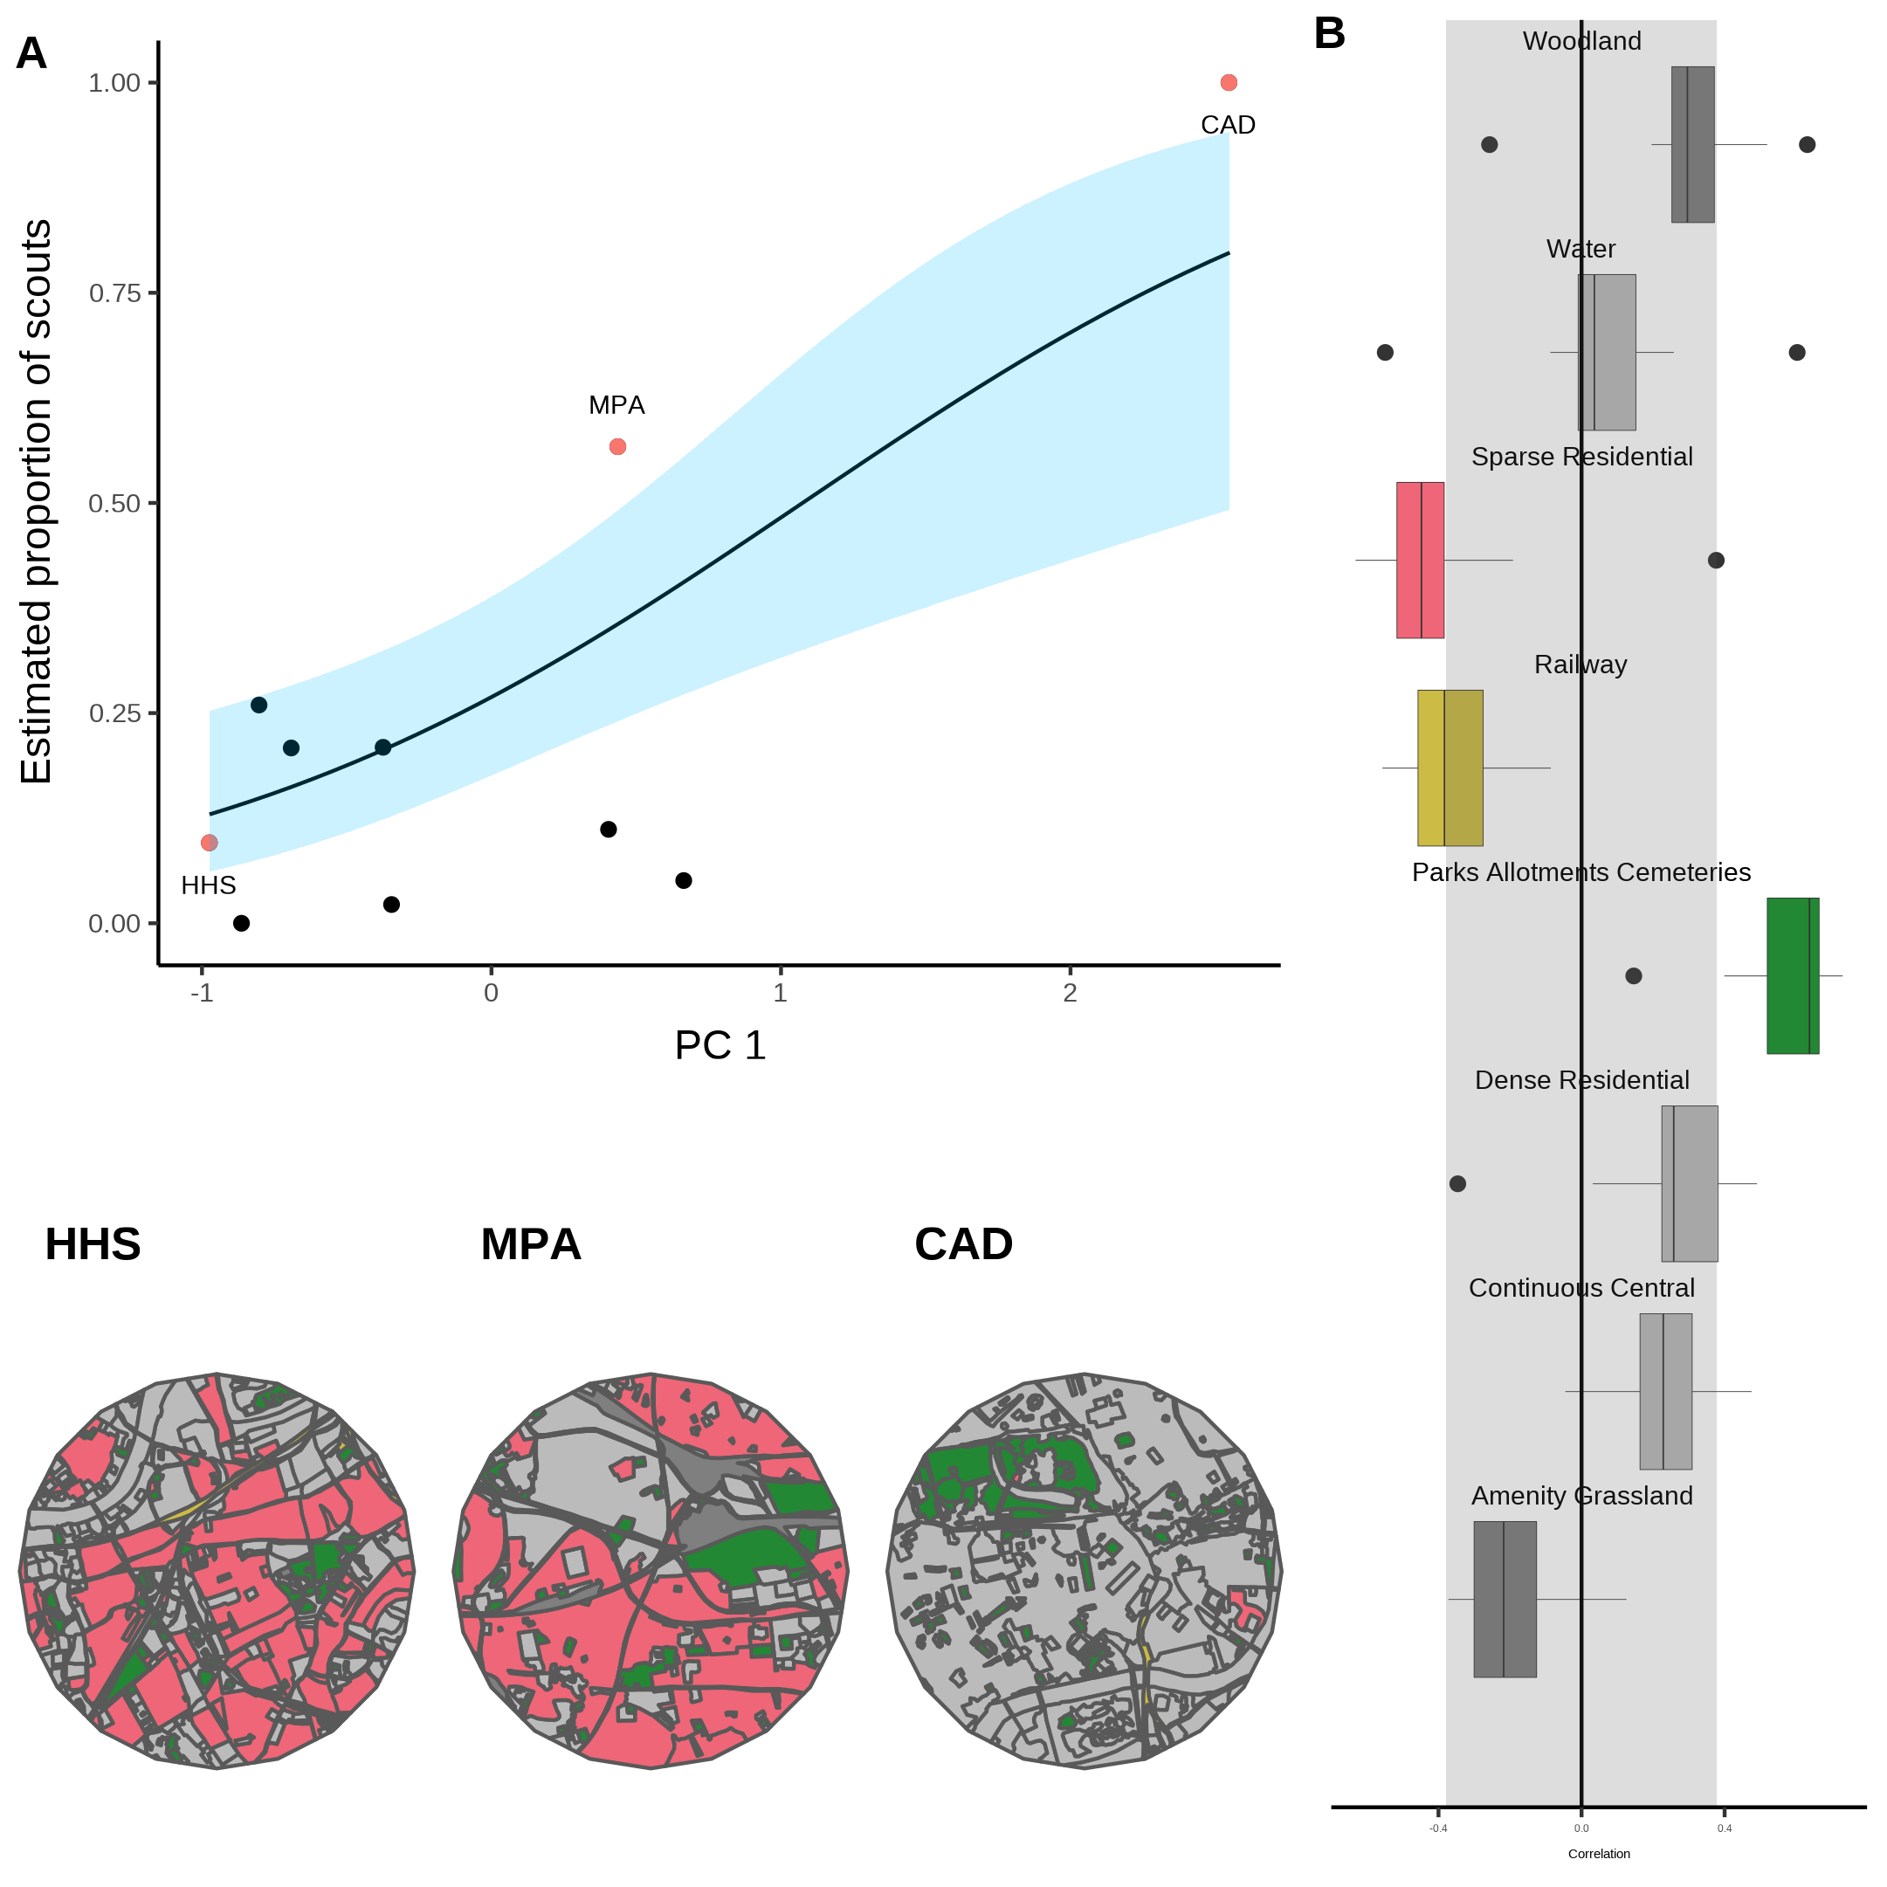

Figure 5. A. Estimated proportion of scouts for each site in the urban landscape against the first principle component derived from a Partial Least Squares analysis of land-use type. A beta regression shows the relationship (black line) between PC1 and the proportion of scouts, with 95% CI shown by the blue shaded area. B. Loadings for PC1 showing the correlations between PC1 and each land-use type. All points outside the shaded area significantly contribute to PC1. The colours of these land-use types are shown in the local environment of sites HHS, MPA and CAD (maps in bottom left) chosen as representative sites along the model gradient.

Across both environments our results hint at a decrease in reliance on waggle dance recruitment as resources become harder to find and foraging trips become longer (Samuelson, Schürch, and Leadbeater 2021). Arable land is likely to be nutritionally poor for pollinators (note that oilseed rape field and fruit crops were not included in this category), while residential areas -particularly gardens- are considered nutritional hotspots for bees (Baldock et al. 2019). Similarly, in the urban environments sparse-residential coverage correlated negatively with the proportion of scout trips. However, we are cautious in this interpretation for two reasons. Firstly, because our study was designed as a proof-of-principle based on an existing dataset, we did not systematically assess the availability of forage within these sites. Secondly, although we saw a similar pattern in the urban data for sparse residential areas (35% of land-cover), which correlated negatively with the proportion of scout trips, this pattern reversed when a highly influential site (CAD; identified by the jacknifed PLS) was removed, and we also found parks, allotments and cemeteries (8% land cover), which could be expected to provide abundant forage for bees (Baldock et al. 2019), to correlate positively with independent search.

The fitting of our model to waggle dance observations provides a novel tool to quantify the relative importance of social and private information in honeybees. Whilst recruitment is well known to occur through other mechanisms besides the waggle dance, such as through olfactory cues, the exceptionally close fit of our model to waggle run durations underlines the importance of the waggle dance in honey bee foraging. Further, by identifying the land-use combinations which most influence variation in the proportion of scouts, our analysis allows us to map the environment along the major axis of honeybee information use and visualise how land-use influences the use of the waggle dance.

Our results within the agri-rural sites are in broad agreement with other studies which evaluated foraging performance with and without the dance (Dornhaus et al. 2006; Price et al. 2019). These results suggest that, even though collective foraging is not always beneficial, that in environments where high quality resources are present, but relatively scarce, collective foraging is being carried out by colonies, suggesting that under these conditions exchanging social information through the waggle dance confers benefits. These benefits of dancing appear to outweigh the costs associated with dancing and could explain why this remarkable behaviour is present in modern-day bees. However, the results for our urban sites do not produce a clear biological rational and present an all together more varied picture. An alternative hypothesis could be that the the dance is influenced by resource stability more than abundance and that longer term effects may contribute to the benefits of the dance (Schürch and Gruẗer 2014). Whilst the limiting number of sites used in this study handicaps our ability to progress this debate here, as a proof of concept, the methods derived here provide a new toolkit for evaluating factors influencing waggle dance recruitment

The analysis of waggle dance data can make an important contribution to our understanding of social information use and provides a methodology to further evaluate how honey bees use their unique dance language. Recently, technological advances have emerged which enable colony metrics to be collected faster, more accurately and over greater time spans than could be gathered by hand, allowing individuals to be tracked within colonies and theories of individual behaviour to be evaluated in more depth than could have been done previously (Wild et al. 2021). By piecing together the behavioural response of individuals and combining these with landscape analyses, we have found a mathematical description of colony foraging which extends our ability to predict individual behaviour beyond the colony walls and in to the environment. With the advances in the decoding of the waggle dance through automated methods (Wario et al. 2017), we face the prospect of waggle dance data becoming “big data”. Our methodology thus provides a means of analysing such large data sets to inform the debate about the importance of social information, as well as providing useful colony metrics of foraging activity.

# References

Baldock, Katherine C.R., Mark A. Goddard, Damien M. Hicks, William E. Kunin, Nadine Mitschunas, Helen Morse, Lynne M. Osgathorpe, et al. 2019. “A systems approach reveals urban pollinator hotspots and conservation opportunities.” *Nature Ecology and Evolution* 3 (3): 363–73. <https://doi.org/10.1038/s41559-018-0769-y>.

Beekman, Madeleine, Amy L. Gilchrist, Michael Duncan, and David J.T. Sumpter. 2007. “What makes a honeybee scout?” *Behavioral Ecology and Sociobiology* 61 (7): 985–95. <https://doi.org/10.1007/S00265-006-0331-9>.

Boch, Rudolf. 1956. “Die Tänze der Bienen bei nahen und fernen Trachtquellen.” *Zeitschrift Für Vergleichende Physiologie* 38 (1-2): 136–67. <https://doi.org/10.1007/BF00338624>.

Burnham, K.P., and D.R. Anderson. 2002. *Model Selection and Multimodel Inference: A Practical Information-Theoretic Approach.* 2nd ed. New York: Springer New York. <https://doi.org/10.1007/b97636>.

Carrascal, Luis M., Ismael Galván, and Oscar Gordo. 2009. “Partial least squares regression as an alternative to current regression methods used in ecology.” *Oikos* 118 (5): 681–90. <https://doi.org/10.1111/J.1600-0706.2008.16881.X>.

Couvillon, Margaret J., Fiona C. Riddell Pearce, Elisabeth L. Harris-Jones, Amanda M. Kuepfer, Samantha J. Mackenzie-Smith, Laura A. Rozario, Roger Schürch, and Francis L. W. Ratnieks. 2012. “Intra-dance variation among waggle runs and the design of efficient protocols for honey bee dance decoding.” *Biology Open* 1 (5): 467–72. <https://doi.org/10.1242/BIO.20121099>.

Dornhaus, Anna, Franziska Klügl, Christoph Oechslein, Frank Puppe, and Lars Chittka. 2006. “Benefits of recruitment in honey bees: effects of ecology and colony size in an individual-based model.” *Behavioral Ecology* 17 (3): 336–44. <https://doi.org/10.1093/beheco/arj036>.

Esch, Harald. 1961. “Über die Schallerzeugung beim Werbetanz der Honigbiene.” *Zeitschrift Für Vergleichende Physiologie* 45 (1): 1–11. <https://doi.org/10.1007/BF00297754>.

Frisch, Karl von. 1967. *The Dance Language and Orientation of Bees*. Harvard University Press. <https://doi.org/10.4159/harvard.9780674418776>.

Goldstein, M. L., S. A. Morris, and G. G. Yen. 2004. “Problems with fitting to the power-law distribution.” *The European Physical Journal B - Condensed Matter and Complex Systems 2004 41:2* 41 (2): 255–58. <https://doi.org/10.1140/EPJB/E2004-00316-5>.

Grüter, Christoph, and Walter M. Farina. 2009. “The honeybee waggle dance: can we follow the steps?” *Trends in Ecology & Evolution* 24 (5): 242–47. <https://doi.org/10.1016/J.TREE.2008.12.007>.

Grüter, Christoph, and Francis L.W. Ratnieks. 2011. “Honeybee foragers increase the use of waggle dance information when private information becomes unrewarding.” *Animal Behaviour* 81 (5): 949–54. <https://doi.org/10.1016/j.anbehav.2011.01.014>.

Grüter, Christoph, Francisca H.I.D. Segers, and Francis L.W. Ratnieks. 2013. “Social learning strategies in honeybee foragers: Do the costs of using private information affect the use of social information?” *Animal Behaviour* 85 (6): 1443–9. <https://doi.org/10.1016/j.anbehav.2013.03.041>.

Hasenjager, Matthew J., William Hoppitt, and Ellouise Leadbeater. 2022. “Do honey bees modulate dance following according to foraging distance?” *Animal Behaviour* 184 (February): 89–97. <https://doi.org/10.1016/j.anbehav.2021.12.010>.

Kirchner, Wolfgang H., and Andreas Grasser. 1998. “The significance of odor cues and dance language information for the food search behavior of honeybees (Hymenoptera: Apidae).” *Journal of Insect Behavior* 11 (2): 169–78. <https://doi.org/10.1023/A:1021098405564>.

Nürnberger, Fabian, Ingolf Steffan-Dewenter, and Stephan Härtel. 2017. “Combined effects of waggle dance communication and landscape heterogeneity on nectar and pollen uptake in honey bee colonies.” *PeerJ* 2017 (6): e3441. <https://doi.org/10.7717/PEERJ.3441/SUPP-4>.

Price, R. I.Anson, N. Dulex, N. Vial, C. Vincent, and C. Grüter. 2019. “Honeybees forage more successfully without the ‘dance language’ in challenging environments.” *Science Advances* 5 (2). <https://doi.org/10.1126/sciadv.aat0450>.

Price, Robbie I.Anson, and Christoph Grüter. 2015. “Why, when and where did honey bee dance communication evolve?” *Frontiers in Ecology and Evolution* 3 (NOV): 125. <https://doi.org/10.3389/FEVO.2015.00125/BIBTEX>.

Pyke, Graham H. 1978. “Optimal foraging in bumblebees and coevolution with their plants.” *Oecologia 1978 36:3* 36 (3): 281–93. <https://doi.org/10.1007/BF00348054>.

Samuelson, Ash E., and Ellouise Leadbeater. 2018. “A land classification protocol for pollinator ecology research: An urbanization case study.” *Ecology and Evolution* 8 (11): 5598–5610. <https://doi.org/10.1002/ECE3.4087>.

Samuelson, Ash E., Roger Schürch, and Ellouise Leadbeater. 2021. “Dancing bees evaluate central urban forage resources as superior to agricultural land.” *Journal of Applied Ecology*. <https://doi.org/10.1111/1365-2664.14011>.

Schürch, Roger, and Christoph Gruẗer. 2014. “Dancing Bees Improve Colony Foraging Success as Long-Term Benefits Outweigh Short-Term Costs.” *PLOS ONE* 9 (8): e104660. <https://doi.org/10.1371/JOURNAL.PONE.0104660>.

Schürch, Roger, Keiran Zwirner, Bethany J. Yambrick, Tiffanie Pirault, James M. Wilson, and Margaret J. Couvillon. 2019. “Dismantling Babel: creation of a universal calibration for honey bee waggle dance decoding.” *Animal Behaviour* 150 (April): 139–45. <https://doi.org/10.1016/j.anbehav.2019.01.016>.

Seeley, TD. 1995. *The Wisdom of the Hive*. <https://doi.org/10.1016/j.desal.2010.03.003>.

Seeley, Thomas D. 1994. “Honey bee foragers as sensory units of their colonies.” *Behavioral Ecology and Sociobiology* 34 (1): 51–62. <https://doi.org/10.1007/BF00175458>.

Seeley, Thomas D, Scott Camazine, and James Sneyd. 1991. “Collective decision-making in honey bees: how colonies choose among nectar sources.” *Behavioral Ecology and Sociobiology* 28 (4): 277–90. <https://doi.org/10.1007/BF00175101>.

Seeley, Thomas D., Alexander S. Mikheyev, and Gary J. Pagano. 2000. “Dancing bees tune both duration and rate of waggle-run production in relation to nectar-source profitability.” *Journal of Comparative Physiology - A Sensory, Neural, and Behavioral Physiology* 186 (9): 813–19. <https://doi.org/10.1007/s003590000134>.

Seeley, Thomas D., and Craig A. Tovey. 1994. “Why search time to find a food-storer bee accurately indicates the relative rates of nectar collecting and nectar processing in honey bee colonies.” *Animal Behaviour* 47 (2): 311–16. <https://doi.org/10.1006/anbe.1994.1044>.

Seeley, Thomas D., and William F. Towne. 1992. “Tactics of dance choice in honey bees: do foragers compare dances?” *Behavioral Ecology and Sociobiology* 30 (1): 59–69. <https://doi.org/10.1007/BF00168595>.

Sherman, Gavin, and P. Kirk Visscher. 2002. “Honeybee colonies achieve fitness through dancing.” *Nature* 419 (6910): 920–22. <https://doi.org/10.1038/nature01127>.

Sumpter, D. J.T. 2006. “The principles of collective animal behaviour.” *Philosophical Transactions of the Royal Society B: Biological Sciences* 361 (1465): 5–22. <https://doi.org/10.1098/rstb.2005.1733>.

Wario, Fernando, Benjamin Wild, Raúl Rojas, and Tim Landgraf. 2017. “Automatic detection and decoding of honey bee waggle dances.” *PLOS ONE* 12 (12): e0188626. <https://doi.org/10.1371/JOURNAL.PONE.0188626>.

Wild, Benjamin, David M. Dormagen, Adrian Zachariae, Michael L. Smith, Kirsten S. Traynor, Dirk Brockmann, Iain D. Couzin, and Tim Landgraf. 2021. “Social networks predict the life and death of honey bees.” *Nature Communications 2021 12:1* 12 (1): 1–12. <https://doi.org/10.1038/s41467-021-21212-5>.